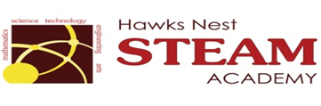School Counseling Program Newsletter
Shandrai Silva, School Counselor | April 2017

Counselor Message  Happy Spring! In just a few short months, we will be at the end of another school year. Hard to believe! It has been a fabulous school year so far. We are looking forward to another great month at Hawks Nest STEAM Academy.  In March, our students had an opportunity to participate in a school-wide service project. We collected money to support the Leukemia & Lymphoma Society, an organization dedicated to funding research, finding cures and ensuring access to treatments for blood cancer patients. Together, we collected over $3400. Congratulations to Ms. Greer’s class, our top fundraising class and winner of the pasta lunch. Thank you for supporting this effort!  This month in classroom guidance, we will continue to learn about College and Careers. We are excited about Career Day on April 12th.  As we approach the end of the school year, please encourage students to keep working hard and to do their best always.  How to See the School Counselor  Classroom guidance classes weekly or biweekly based on grade levels specials schedule. Small group and individual counseling by self -referral, parent referral, teacher referral, administrator referral or counselor initiated.  Contact School Counselor at 704-866-8467 or sosilva@gaston.k12.nc.us | Home of the Hawks    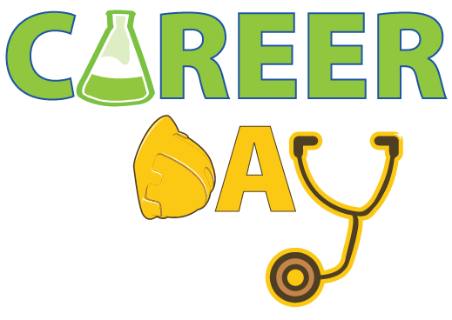  Wednesday, April 12, 2017  *Wear College Tshirt/Shirt  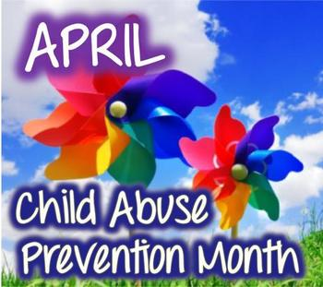  https://www.childwelfare.gov/topics/preventing/preventionmonth/  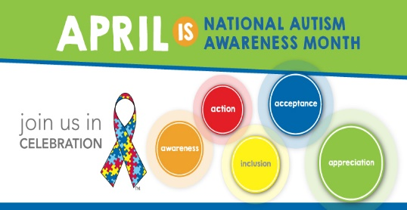 | Character Education  “We’re Soaring with Good Character”  ______________________________  The character trait of the month is Honesty. Honesty means being truthful in what you say and do.  ________________________________    “Intelligence plus character- that is  the goal of true education.”  Dr. Martin L. King, Jr.    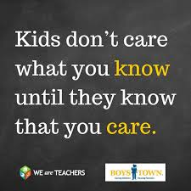
http://www.autism-society.org/get-involved/national-autism-awareness-month/

